Angola

## Population Data

The data set shows the political stability estimate of the country each year.

## # A tibble: 23 x 5  
## country iso3c date population popCategory5  
## <chr> <chr> <dbl> <dbl> <chr>   
## 1 Angola AGO 1996 14400719 small   
## 2 Angola AGO 1997 14871570 small   
## 3 Angola AGO 1998 15359601 small   
## 4 Angola AGO 1999 15866869 small   
## 5 Angola AGO 2000 16395473 small   
## 6 Angola AGO 2001 16945753 small   
## 7 Angola AGO 2002 17519417 small   
## 8 Angola AGO 2003 18121479 small   
## 9 Angola AGO 2004 18758145 small   
## 10 Angola AGO 2005 19433602 small   
## 11 Angola AGO 2006 20149901 small   
## 12 Angola AGO 2007 20905363 small   
## 13 Angola AGO 2008 21695634 small   
## 14 Angola AGO 2009 22514281 small   
## 15 Angola AGO 2010 23356246 small   
## 16 Angola AGO 2011 24220661 small   
## 17 Angola AGO 2012 25107931 medium   
## 18 Angola AGO 2013 26015780 medium   
## 19 Angola AGO 2014 26941779 medium   
## 20 Angola AGO 2015 27884381 medium   
## 21 Angola AGO 2016 28842484 medium   
## 22 Angola AGO 2017 29816748 medium   
## 23 Angola AGO 2018 30809762 medium

## # A tibble: 23 x 5  
## country iso3c date popGrowth popGrowthCat5   
## <chr> <chr> <dbl> <dbl> <chr>   
## 1 Angola AGO 1996 3.21 high growth rate  
## 2 Angola AGO 1997 3.22 high growth rate  
## 3 Angola AGO 1998 3.23 high growth rate  
## 4 Angola AGO 1999 3.25 high growth rate  
## 5 Angola AGO 2000 3.28 high growth rate  
## 6 Angola AGO 2001 3.30 high growth rate  
## 7 Angola AGO 2002 3.33 high growth rate  
## 8 Angola AGO 2003 3.38 high growth rate  
## 9 Angola AGO 2004 3.45 high growth rate  
## 10 Angola AGO 2005 3.54 high growth rate  
## 11 Angola AGO 2006 3.62 high growth rate  
## 12 Angola AGO 2007 3.68 high growth rate  
## 13 Angola AGO 2008 3.71 high growth rate  
## 14 Angola AGO 2009 3.70 high growth rate  
## 15 Angola AGO 2010 3.67 high growth rate  
## 16 Angola AGO 2011 3.63 high growth rate  
## 17 Angola AGO 2012 3.60 high growth rate  
## 18 Angola AGO 2013 3.55 high growth rate  
## 19 Angola AGO 2014 3.50 high growth rate  
## 20 Angola AGO 2015 3.44 high growth rate  
## 21 Angola AGO 2016 3.38 high growth rate  
## 22 Angola AGO 2017 3.32 high growth rate  
## 23 Angola AGO 2018 3.28 high growth rate

## Population trend

The plot shows the population trend of the country.

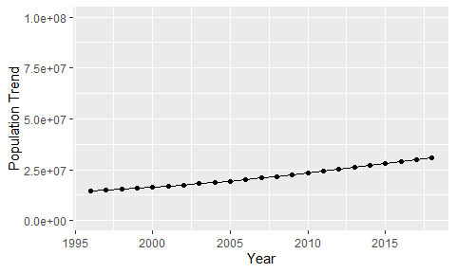

Political Stability Trend

# Population growth graph

The plot shows the population growth rate trend of the country.

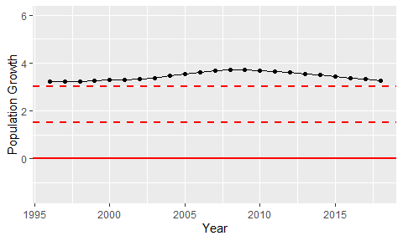

Population Growth Trend